# Booth Algorithm:

**EXP NO:34**

# AIM: To write a C program to implement Booth Algorithm

**APPARATUS:** DEV C++

**ALGORITHM:**

These observations form the basis of Booth's algorithm:

It is possible to use left shift operations to multiply by two.

Right-shift operations like division by two are possible.

If a binary number consists of a string of consecutive 1s and then 0s, we can replace this string with a single 1 and then the same amount of 0s, and the resulting number will be equal to the original number.

These findings enable the following steps to be used to define Booth's algorithm:

Set the item's initial value to 0.

Consider expressing the two binary numbers that will be multiplied as two's complements.

To make the multiplier's length equal to the multiplicand's length, add a zero bit to the right of the multiplier.

Examine two bits at a time, beginning with the multiplier's rightmost bit.

Subtract the multiplicand from the product if the first two bits are 0 and 1s.

If both bits are 1 and 0, double the product by the multiplicand.

Right-shift the multiplier by one bit.

Up until all multiplier bits have been checked, repeat steps 4-7.

**PROGRAM:**

#include <stdio.h>  
#include <math.h>  
 int a = 0,b = 0, c = 0, a1 = 0, b1 = 0, com[5]= { 1, 0, 0, 0, 0};  
int anum[5] = {0}, anumcp[5] = {0}, bnum[5] = {0};  
int acomp[5] = {0}, bcomp[5] = {0}, pro[5] = {0}, res[5] = {0};  
void binary(){  
     a1 = fabs(a);  
     b1 = fabs(b);  
     int r, r2, i, temp;  
     for (i = 0; i < 5; i++){  
           r = a1 % 2;  
           a1 = a1 / 2;  
           r2 = b1 % 2;  
           b1 = b1 / 2;  
           anum[i] = r;  
           anumcp[i] = r;  
           bnum[i] = r2;  
           if(r2 == 0){   
                bcomp[i] = 1;  
           }  
           if(r == 0){  
                acomp[i] =1;  
           }  
    }  
    
//part for two's complementing  
c = 0;  
  
for ( i = 0; i < 5; i++){  
           res[i] = com[i]+ bcomp[i] + c;  
           if(res[i] >= 2){  
                c = 1;  
           }  
           else  
                c = 0;  
           res[i] = res[i] % 2;  
     }  
  
for (i = 4; i >= 0; i--){  
     bcomp[i] = res[i];  
    
}  
  
//in case of negative inputs  
    
if (a < 0){  
      c = 0;  
     for (i = 4; i >= 0; i--){  
           res[i] = 0;  
     }  
     for ( i = 0; i < 5; i++){  
           res[i] = com[i] + acomp[i] + c;  
           if (res[i] >= 2){  
  
  
                c = 1;  
  
  
           }  
  
  
           else  
  
  
                c = 0;  
  
  
           res[i] = res[i]%2;  
  
  
     }  
  
  
     for (i = 4; i >= 0; i--){  
  
  
           anum[i] = res[i];  
  
  
           anumcp[i] = res[i];  
  
  
     }  
  
  
   
  
  
    
}  
  
  
    
if(b < 0){  
  
  
     for (i = 0; i < 5; i++){  
  
  
           temp = bnum[i];  
  
  
           bnum[i] = bcomp[i];  
  
  
           bcomp[i] = temp;  
  
  
     }  
  
  
    
}  
  
  
}  
  
  
void add(int num[]){  
  
  
     
int i;  
  
  
     
c = 0;  
  
  
     
for ( i = 0; i < 5; i++){  
  
  
           res[i] = pro[i] + num[i] + c;  
  
  
           if (res[i] >= 2){  
  
  
                c = 1;  
  
  
           }  
  
  
           else{  
  
  
                c = 0;  
  
  
           }  
  
  
           res[i] = res[i]%2;  
  
  
     }  
  
  
     for (i = 4; i >= 0; i--){  
  
  
         pro[i] = res[i];  
  
  
         printf("%d",pro[i]);  
  
  
     }  
  
  
    
printf(":");  
  
  
    
for (i = 4; i >= 0; i--){  
  
  
           printf("%d", anumcp[i]);  
  
  
     }  
  
  
}  
  
  
void arshift(){//for arithmetic  
shift right  
  
  
     
int temp = pro[4], temp2 = pro[0], i;  
  
  
     
for (i = 1; i < 5  ;  
i++){//shift the MSB of product  
  
  
       pro[i-1] = pro[i];  
  
  
     
}  
  
  
     
pro[4] = temp;  
  
  
     
for (i = 1; i < 5  ;  
i++){//shift the LSB of product  
  
  
        anumcp[i-1] = anumcp[i];  
  
  
     
}  
  
  
     
anumcp[4] = temp2;  
  
  
     
printf("\nAR-SHIFT: ");//display together  
  
  
     
for (i = 4; i >= 0; i--){  
  
  
        printf("%d",pro[i]);  
  
  
     
}  
  
  
     
printf(":");  
  
  
     
for(i = 4; i >= 0; i--){  
  
  
        printf("%d", anumcp[i]);  
  
  
     
}  
  
  
}  
  
  
   
  
  
void main(){  
  
  
    
int i, q = 0;  
  
  
    
printf("\t\tBOOTH'S MULTIPLICATION ALGORITHM");  
  
  
    
printf("\nEnter two numbers to multiply: ");  
  
  
    
printf("\nBoth must be less than 16");  
  
  
    
//simulating for two numbers each below 16  
  
  
    
do{  
  
  
        printf("\nEnter A: ");  
  
  
        scanf("%d",&a);  
  
  
        printf("Enter B: ");  
  
  
        scanf("%d", &b);  
  
  
     }while(a >=16 || b >=16);  
  
  
   
  
  
     
printf("\nExpected product = %d", a * b);  
  
  
     
binary();  
  
  
     
printf("\n\nBinary Equivalents are: ");  
  
  
     
printf("\nA = ");  
  
  
     
for (i = 4; i >= 0; i--){  
  
  
        printf("%d", anum[i]);  
  
  
     
}  
  
  
     
printf("\nB = ");  
  
  
     
for (i = 4; i >= 0; i--){  
  
  
        printf("%d", bnum[i]);  
  
  
     
}  
  
  
     
printf("\nB'+ 1 = ");  
  
  
     
for (i = 4; i >= 0; i--){  
  
  
        printf("%d", bcomp[i]);  
  
  
     
}  
  
  
     
printf("\n\n");  
  
  
     
for (i = 0;i < 5; i++){  
  
  
           if (anum[i] == q){//just shift for  
00 or 11  
  
  
               printf("\n-->");  
  
  
               arshift();  
  
  
               q = anum[i];  
  
  
           }  
  
  
           else if(anum[i] == 1 && q ==  
0){//subtract and shift for 10  
  
  
              printf("\n-->");  
  
  
              printf("\nSUB B: ");  
  
  
              add(bcomp);//add two's complement  
to implement subtraction  
  
  
              arshift();  
  
  
              q = anum[i];  
  
  
           }  
  
  
           else{//add ans shift for 01  
  
  
              printf("\n-->");  
  
  
              printf("\nADD B: ");  
  
  
              add(bnum);  
  
  
              arshift();  
  
  
              q = anum[i];  
  
  
           }  
  
  
     }  
  
  
   
  
  
     printf("\nProduct is = ");  
  
  
     for  
(i = 4; i >= 0; i--){  
  
  
           printf("%d", pro[i]);  
  
  
     }  
  
  
     for (i = 4; i >= 0; i--){  
  
  
           printf("%d", anumcp[i]);  
  
  
     }  
  
  
}

**INPUT:**

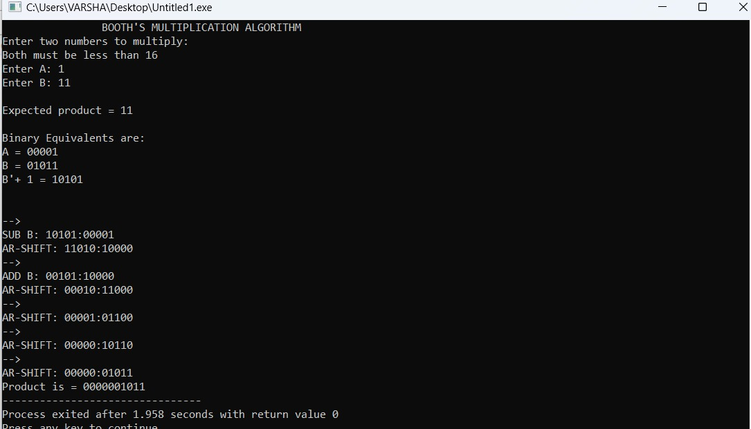

**OUTPUT:**



**RESULT:** Thus, the program was executed successfully using DevC++.